14.1.9 Editors - Movie Clip Editor - Header - Mask Mode - Mask Menu
Mask Menu 2
Transform 2
Move 2
Last Operator Move 2
Values 2
Axis Ortho 2
Orientation 3
Proportional Editing 3
Proportional Editing Falloff 3
Proportional size 3
Connected 3
Projected ( 2D) 3
Rotate 3
Last Operator Rotate 3
Angle 3
Axis 3
Orientation 3
Proportional Editing 4
Proportional Editing Falloff 4
Proportional size 4
Connected 4
Projected ( 2D) 4
Scale 4
Last Operator Resize 4
Scale X Y Z 4
Orientation 4
Proportional Editing 4
Proportional Editing Falloff 4
Proportional size 5
Connected 5
Projected ( 2D) 5
Scale Feather 5
Last Operator Transform 5
Values 5
Axis 5
Orientation 5
Proportional Editing 5
Proportional Editing Falloff 5
Proportional size 6
Connected 6
Projected ( 2D) 6
Clear Feather Weight 6
Duplicate 6
Delete 6
Copy Splines 6
Paste Splines 6
Make Parent 6
Clear Parent 6
Toggle Cyclic 6
Switch Direction 6
Recalc Normals 6
Set Handle Type 7
Animation 7
Insert Shape Key 7
Clear Shape Key 7
Reset Feather Animation 7
Re-key Shape points 7
Show / Hide 7
Show Hidden 7
Hide Selected 7
Hide Unselected 7
Last operator Hide Layer 7
Unselected 7

Mask Menu

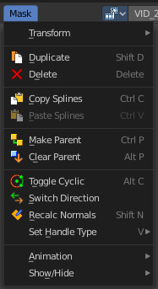

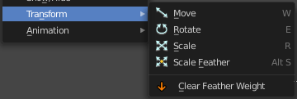
Transform

Move
Move the selected curve spline or points.

Last Operator Move

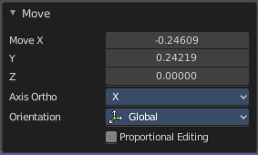
Values
Adjust the move amount.
X, Y and Z defines the position.

Axis Ortho
Along which axis to move.

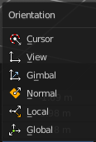
Orientation
Orientation is a drop-down box where you can choose the type of orientation for the transform action.

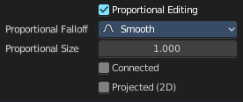
Proportional Editing
Proportional Editing is a drop-down box where you can choose to use proportional editing. When you choose one of the active methods then the neighbor geometry gets influenced too in a proportional way.

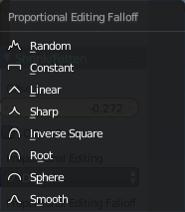
Proportional Editing Falloff
Proportional Editing Falloff is a drop-down box where you can choose a method for the falloff for the proportional editing.

Proportional size
Proportional size is an edit box to Adjust the strength of the Proportional falloff.

Connected
Just edit geometry that is directly connected with the current selection. 4 Bforartists 2 Reference Manual - 7.1.4 Editors - 3D View - Header - Navigation Menu

Projected ( 2D)
Edit geometry that is in 2d space aligned with the current selection. This one goes from the current view in depth direction.

Rotate
Rotate the selected curve spline or points.

Last Operator Rotate

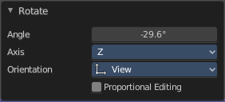
Angle
Adjust the angle.

Axis
Along which axis to rotate

Orientation
Orientation is a drop-down box where you can choose the type of orientation for the transform action.

Proportional Editing
Proportional Editing is a drop-down box where you can choose to use proportional editing. When you choose one of the active methods then the neighbor geometry gets influenced too in a proportional way.

Proportional Editing Falloff
Proportional Editing Falloff is a drop-down box where you can choose a method for the falloff for the proportional editing.

Proportional size
Proportional size is an edit box to adjust the strength of the Proportional falloff.

Connected
Just edit geometry that is directly connected with the current selection. 4 Bforartists 2 Reference Manual - 7.1.4 Editors - 3D View - Header - Navigation Menu

Projected ( 2D)
Edit geometry that is in 2d space aligned with the current selection. This one goes from the current view in depth direction.

Scale
Scale the selected curve spline or points.

Last Operator Resize

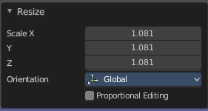
Scale X Y Z
Adjust the scaling.

Orientation
Orientation is a drop-down box where you can choose the type of orientation for the transform action.

Proportional Editing
Proportional Editing is a drop-down box where you can choose to use proportional editing. When you choose one of the active methods then the neighbor geometry gets influenced too in a proportional way.

Proportional Editing Falloff
Proportional Editing Falloff is a drop-down box where you can choose a method for the falloff for the proportional editing.

Proportional size
Proportional size is an edit box to adjust the strength of the Proportional falloff.

Connected
Just edit geometry that is directly connected with the current selection. 4 Bforartists 2 Reference Manual - 7.1.4 Editors - 3D View - Header - Navigation Menu

Projected ( 2D)
Edit geometry that is in 2d space aligned with the current selection. This one goes from the current view in depth direction.

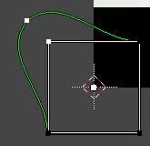
Scale Feather
Scale feather weight for the selected points.
The curve type that is used to create mask splines is almost a Bezier curve. But it has some differences. Smooth edges of the mask are defined by feathering. The curve needed to support feathering in a way that stuck to the curve as you edited it, for ease of editing an animation. These are called S-Curves.
Besides the handles, every control point also has points that define the feather between the current point and the next point on the spline. Each feather point is stored in UV space, where U means position across spline segment, and V means distance between main spline and feather points.

Last Operator Transform

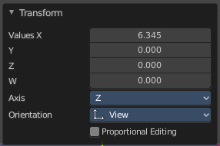
Values
Adjust the scale amount.
X, Y and Z defines the position. W defines the rotation.

Axis
Around which axis to rotate. X, Y or Z.

Orientation
Orientation is a drop-down box where you can choose the type of orientation for the transform action.

Proportional Editing
Proportional Editing is a drop-down box where you can choose to use proportional editing. When you choose one of the active methods then the neighbor geometry gets influenced too in a proportional way.

Proportional Editing Falloff
Proportional Editing Falloff is a drop-down box where you can choose a method for the falloff for the proportional editing.

Proportional size
Proportional size is an edit box to adjust the strength of the Proportional falloff.

Connected
Just edit geometry that is directly connected with the current selection. 4 Bforartists 2 Reference Manual - 7.1.4 Editors - 3D View - Header - Navigation Menu

Projected ( 2D)
Edit geometry that is in 2d space aligned with the current selection. This one goes from the current view in depth direction.

Clear Feather Weight
Reset the feather weight to zero.

Duplicate
Duplicates the selected curve and moves it.

Delete
Deletes the selected mask curve point.

Copy Splines
Copies the currently selected spline.

Paste Splines
Pastes a copied spline.

Make Parent
Set the mask's parenting.

Clear Parent
Clears the mask's parenting.

Toggle Cyclic
Make the spline closed or open.

Switch Direction
Switch the direction in which the spline points. A spline has a direction. A starting point and an endpoint. By switching the starting point becomes the end point, the end point becomes the starting point.

Recalc Normals
Recalculate the direction of the selected spline handlers.

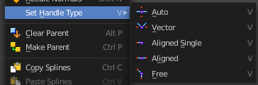
Set Handle Type
In this sub menu you can set the handle type for the currently selected spline points.

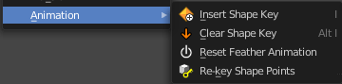
Animation

Insert Shape Key
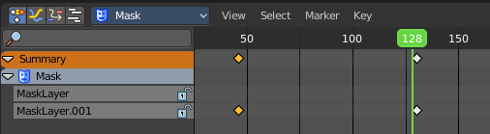
Inserts a shape key keyframe.
The inserted keyframes can then be found in the dope sheet editor in mask mode.

Clear Shape Key
Clears an existing shape key keyframe.

Reset Feather Animation
Resets the feather offset across all animated frames.

Re-key Shape points
Recalculate animation data on selected points for frames selected in the dope sheet.

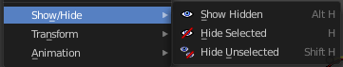
Show / Hide

Show Hidden
Reveals all hidden curves

Hide Selected
Hides the selected curve.

Hide Unselected
Hides the unselected curves.

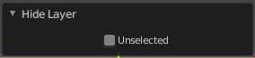
Last operator Hide Layer

Unselected
Hide selected or unselected curves.

